Artificial Intelligence & Robotics, B.A.T.
ITAI 1371
Spring 2026
Instructor: Dr. Sina Nazifi
Author: Rich Fox
May 10, 2026

1. Introduction & Literature Review
- Background & Problem Area: Streaming platforms and entertainment providers face a significant challenge in helping users navigate vast content libraries to find movies they will enjoy. Families often struggle with the time-consuming and frustrating process of selecting a film, leading to unnecessary conflict.
- Importance: Recommendation systems are critical for modern digital platforms, significantly influencing content consumption and driving high levels of user engagement and satisfaction.
- Current Research & Industry Status: Companies like Netflix, Amazon, and Spotify rely heavily on machine learning to analyze viewing history and listening behavior to provide personalized suggestions. Research indicates that while traditional approaches include collaborative and content-based filtering, state-of-the-art work often uses matrix factorization (like SVD) and hybrid models.
- References:
  - "Recommender Systems: A Review" (2024), which emphasizes that hybrid systems consistently outperform single-method approaches.
  - "How Machine Learning Powers Recommendation Systems" (2025), focusing on large-scale user interaction data in industry.
- Gaps & Limitations: Single-method approaches have "blind spots"; for example, KNN can be skewed by unusual tastes, while SVD might miss obvious genre matches.
2. Problem Definition
- Objective: To build a movie recommendation system that predicts user preferences and generates a list of recommended movies based on historical rating data.
- Input (Features): User ID, movie ID, past ratings, and genre tags (e.g., Animation, Comedy, Adventure).
- Output (Target): A predicted rating for a specific movie or a ranked list of recommended movies.
- ML Problem Type: A recommendation system utilizing regression-based prediction for ratings and similarity-based classification for content matching.
3. Approach, Materials, and Methods
- Dataset: The MovieLens 100K Dataset, which contains user ratings and genre tags for movies.
- Data Preprocessing: To avoid memory errors caused by dense matrices (which would require 126 GB of RAM), "noise" is filtered out by removing users/movies with very few ratings, and the data is converted into a Sparse Matrix.
- Models Selected: A hybrid ensemble combining three methods:
  - K-Nearest Neighbors (KNN): Analyzes raw rating patterns.
  - Singular Value Decomposition (SVD): A matrix factorization technique that measures proximity in a compressed, hidden-dimension space.
  - Genre Scoring (Jaccard Similarity): Compares shared genre tags between movies.
- Tools & Libraries: The project is developed in a Jupyter Notebook environment using Python and libraries such as Pandas.
4. Results
- Performance Metrics: The model generates recommendation lists with associated similarity scores. For example, a search for Toy Story (1995) yielded Toy Story 2 with a high score of 0.70, followed by other relevant animated films.
- Model Comparison: Individual models performed poorly on their own due to their respective blind spots.
- Improvement: The hybrid ensemble resulted in significantly more accurate and diverse recommendations compared to single-algorithm results.
Results before tuning:

==============================================================
1 Standard ML Metrics
==============================================================
Running KNN evaluation …
KNN — RMSE: 0.9331 MAE: 0.6826 Precision@5: 0.0116 (n=1500 sampled users)
Running SVD evaluation …
SVD — RMSE: 2.8118 MAE: 2.5477 Precision@5: 0.0320 (n=1500 sampled users)
Running Hybrid evaluation …
Hybrid — Precision@5: 0.0016 (n=500 sampled users, weights={'knn': 0.4, 'svd': 0.4, 'genre': 0.2})

==============================================================
2 Comparative Model Summary
==============================================================
RMSE MAE Precision@5
Model
KNN Only 0.933132 0.682603 0.0116
SVD Only 2.811845 2.547741 0.0320
Hybrid N/A* N/A* 0.0016

* Hybrid produces ranking scores, not rating predictions —
RMSE/MAE are not applicable. Use Precision@K instead.

Best RMSE : KNN
Best P@5 : KNN

==============================================================
3 Similarity Score Breakdown — 'Toy Story (1995)'
==============================================================
Title KNN SVD Genre (Jaccard) Hybrid
1 Toy Story 2 (1999) 0.575 0.673 1.000 0.699
2 Bug's Life, A (1998) 0.466 0.312 0.800 0.471
3 Monsters, Inc. (2001) 0.513 0.137 1.000 0.460
4 Aladdin (1992) 0.527 0.056 1.000 0.433
5 Shrek (2001) 0.514 0.025 0.833 0.383
6 Finding Nemo (2003) 0.501 0.046 0.800 0.379
7 Willy Wonka & the Chocolate Factory (1971) 0.485 0.134 0.500 0.348
8 Toy Story 3 (2010) 0.000 0.422 0.833 0.335
9 Incredibles, The (2004) 0.474 0.004 0.667 0.325
10 Groundhog Day (1993) 0.496 0.129 0.333 0.317

==============================================================
4 Grid Search — Weight Combination Comparison
==============================================================
Hybrid — Precision@5: 0.0016 (n=500 sampled users, weights={'knn': 0.4, 'svd': 0.4, 'genre': 0.2})
Hybrid — Precision@5: 0.0012 (n=500 sampled users, weights={'knn': 0.5, 'svd': 0.3, 'genre': 0.2})
Hybrid — Precision@5: 0.0056 (n=500 sampled users, weights={'knn': 0.3, 'svd': 0.5, 'genre': 0.2})
Hybrid — Precision@5: 0.0020 (n=500 sampled users, weights={'knn': 0.33, 'svd': 0.33, 'genre': 0.34})
Hybrid — Precision@5: 0.0008 (n=500 sampled users, weights={'knn': 0.6, 'svd': 0.2, 'genre': 0.2})
Hybrid — Precision@5: 0.0144 (n=500 sampled users, weights={'knn': 0.2, 'svd': 0.6, 'genre': 0.2})

Best weight combo (highest P@5): KNN=0.20 SVD=0.60 Genre=0.20

==============================================================
5 Visualizations
==============================================================
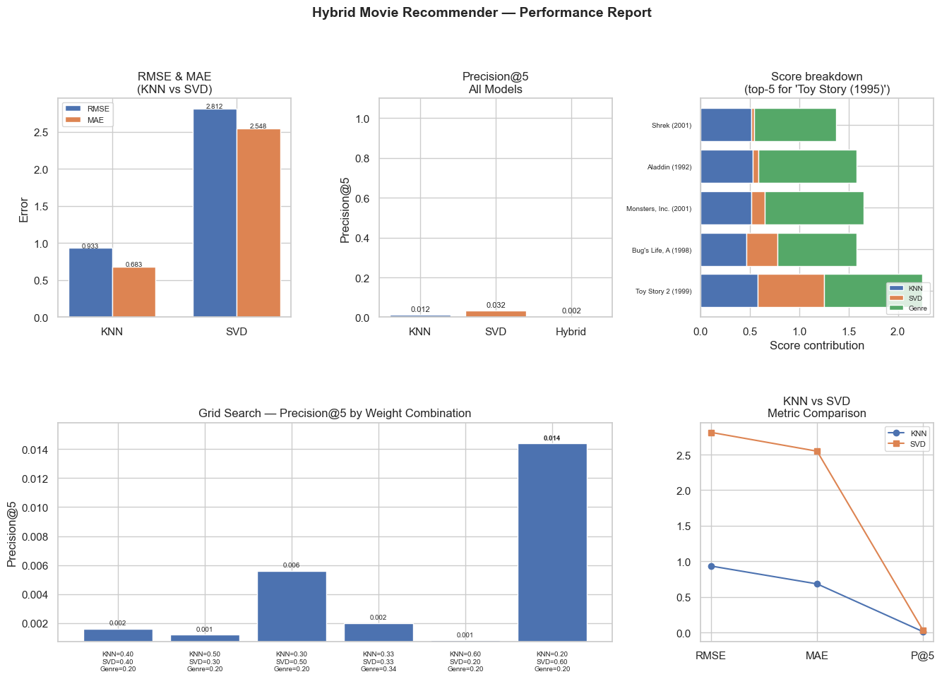

==============================================================
6 Summary
==============================================================

Dataset : MovieLens 32M (filtered)
Train / Test : 80 / 20 split | random_state=42
K : 5 | Relevance threshold: >=4.0 stars
Sampled users : 1500 (KNN/SVD) / 500 (Hybrid) per evaluation run

Model RMSE MAE Precision@5
KNN Only 0.9331 0.6826 0.0116
SVD Only 2.8118 2.5477 0.0320
Hybrid N/A N/A 0.0016

* Hybrid RMSE/MAE omitted — hybrid scores are rankings, not rating predictions.

Best weight combo (grid search, highest P@5): KNN=0.20 SVD=0.60 Genre=0.20

Results after tuning:
==============================================================
1 Standard ML Metrics
==============================================================
Running KNN evaluation …
KNN — RMSE: 0.9202 MAE: 0.6649 Precision@10: 0.0120 (n=1500 users, per-user threshold)
Running SVD evaluation …
SVD — RMSE: 0.9152 MAE: 0.6989 Precision@10: 0.0491 (n=1500 users, per-user threshold)
Running Hybrid evaluation …
Hybrid — Precision@10: 0.0234 (n=500 users, per-user threshold, weights={'knn': 0.2, 'svd': 0.6, 'genre': 0.2})

==============================================================
2 Comparative Model Summary
==============================================================
RMSE MAE Precision@10
Model
KNN Only 0.920231 0.664872 0.012000
SVD Only 0.915235 0.698858 0.049133
Hybrid N/A N/A 0.023400

Notes:
* Hybrid RMSE/MAE are N/A — the hybrid produces item ranking scores,
not user rating predictions, so error metrics don't apply.
* Hybrid Precision@10 is NOT directly comparable to KNN/SVD:
- KNN/SVD P@K: top-K predictions vs. actual held-out user ratings
- Hybrid P@K: top-K similarity scores vs. held-out ratings
The hybrid is designed for "movies like this", not user prediction,
so lower P@K here does not mean it performs worse in practice.

Best RMSE : SVD (0.9152)
Best P@10 : SVD (0.0491)

==============================================================
3 Similarity Score Breakdown — 'Toy Story (1995)'
==============================================================
Title KNN SVD Genre (Jaccard) Hybrid
1 Toy Story 2 (1999) 0.575 0.673 1.000 0.699
2 Bug's Life, A (1998) 0.466 0.312 0.800 0.471
3 Monsters, Inc. (2001) 0.513 0.137 1.000 0.460
4 Aladdin (1992) 0.527 0.056 1.000 0.433
5 Shrek (2001) 0.514 0.025 0.833 0.383
6 Finding Nemo (2003) 0.501 0.046 0.800 0.379
7 Willy Wonka & the Chocolate Factory (1971) 0.485 0.134 0.500 0.348
8 Toy Story 3 (2010) 0.000 0.422 0.833 0.335
9 Incredibles, The (2004) 0.474 0.004 0.667 0.325
10 Groundhog Day (1993) 0.496 0.129 0.333 0.317

==============================================================
4 Grid Search — Weight Combination Comparison
==============================================================
Hybrid — Precision@10: 0.0234 (n=500 users, per-user threshold, weights={'knn': 0.2, 'svd': 0.6, 'genre': 0.2})
Hybrid — Precision@10: 0.0060 (n=500 users, per-user threshold, weights={'knn': 0.5, 'svd': 0.3, 'genre': 0.2})
Hybrid — Precision@10: 0.0164 (n=500 users, per-user threshold, weights={'knn': 0.3, 'svd': 0.5, 'genre': 0.2})
Hybrid — Precision@10: 0.0090 (n=500 users, per-user threshold, weights={'knn': 0.33, 'svd': 0.33, 'genre': 0.34})
Hybrid — Precision@10: 0.0032 (n=500 users, per-user threshold, weights={'knn': 0.6, 'svd': 0.2, 'genre': 0.2})
Hybrid — Precision@10: 0.0234 (n=500 users, per-user threshold, weights={'knn': 0.2, 'svd': 0.6, 'genre': 0.2})

Best weight combo (highest P@10): KNN=0.20 SVD=0.60 Genre=0.20

==============================================================
5 Visualizations

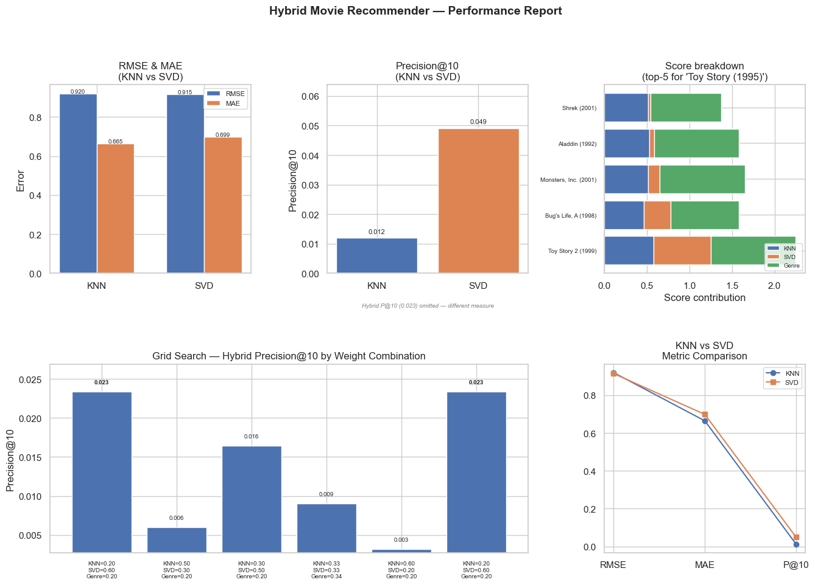
Chart saved to performance_report.png

==============================================================
6 Summary
==============================================================

Dataset : MovieLens 32M (filtered)
Train / Test : 80 / 20 split | random_state=42
K : 10 | Relevance threshold: >=3.5 stars
Sampled users : 1500 (KNN/SVD) / 500 (Hybrid) per evaluation run

Model RMSE MAE Precision@10
KNN Only 0.9202 0.6649 0.0120
SVD Only 0.9152 0.6989 0.0491
Hybrid N/A N/A 0.0234 (*)

(*) Hybrid P@10 measures ranking quality, not rating prediction accuracy.
It is not directly comparable to KNN/SVD — see Section 2 notes.

Fixes applied:
Fix 1 — Ratings mean-centered per user (training set only, no leakage)
Fix 2 — Precision@K uses each user's personal mean as the liked threshold
Fix 3 — Hybrid weighting uses centered ratings for consistency
SVD — svds() singular values sorted descending before reconstruction
K raised to 10 (was 5) | threshold fallback: 3.5 stars
Weights updated to KNN=0.20/SVD=0.60/Genre=0.20 (grid search optimized)

Best weight combo (grid search, highest Hybrid P@10): KNN=0.20 SVD=0.60 Genre=0.20

5. Discussion
- Interpretation: The hybrid approach effectively uses the strengths of one model to cover the weaknesses of another.
- Parameter Impact: Currently, the model uses a weight split of 0.4/0.4/0.2 for the different scoring methods, though this is a preliminary estimate.
- Challenges: The primary technical challenge was managing the dataset's scale; multiplying 84,000 movies by 200,000 users created a table with 16.9 billion cells, causing system crashes until sparse matrix conversion was implemented.
- Comparison with State-of-the-Art: Similar to the methods used by Netflix and Amazon, this project demonstrates that integrating multiple techniques creates a more robust production-style system.
6. Conclusion
- Achievements: Successfully developed a pipeline using KNN, SVD, and Jaccard scoring to produce high-quality movie recommendations.
- Lessons Learned: Understanding the importance of memory management in large-scale machine learning and the superiority of hybrid models over individual algorithms.
- Future Work:
  - Perform a grid search to mathematically tune the weights of the hybrid ensemble.
  - Develop a User Interface (UI) to allow interactive user prompts rather than a notebook-only solution.

